Press release
November 2016

Maximum transfer efficiency for electrostatic coating
Higher coating quality with less material – how is that possible? By using the right equipment! Such as the new GA 5000 electrostatic gun and EPG 5000 control unit.

Increasingly strict regulations mean that companies face the task of further reducing polluting emissions during coating processes. In view of their important contribution towards this aim, electrostatic processes have become successfully established in the market in recent years, and the trend is continuing. It is accompanied by an increase in the use of automated systems, partly due to reducing investment costs for robots. To serve this growing segment, WAGNER has now developed the GA 5000 automatic electrostatic gun and associated EPG 5000 control unit. "The starting point was the GM 5000 manual electrostatic gun which has been very positively received in the market," explained Peter Neu, Senior Product Manager at WAGNER Industrial Solutions. "We have integrated tried-and-tested elements of the GA 4000 automatic gun in this product to ensure easy assembly on both lifting equipment and robots."
Rapid amortisation thanks to efficient coating
The gentle spray jet with low kinetic energy is the secret behind the GA 5000's very high transfer efficiency. "Anyone switching from conventional coating processes to an electrostatic system with the GA 5000 can save between 30 and 50 per cent in materials. Depending on usage, this allows the associated investments to be amortised very quickly, in some cases in less than a year," stated Peter Neu.
Fine atomisation for high coating quality
The GA 5000's special air system also ensures particularly fine atomisation in minimally small droplets. The homogeneous spray jet does not rebound from the workpiece, but coats curves and inaccessible places with a high-quality finish. This speeds up the coating process, reducing coating times by up to 20 per cent and paving the way for significant increases in productivity. The GA 5000's nozzles and air caps can also be replaced under pressure even during low pressure applications, which means that production processes are interrupted for just a few seconds. And maintenance is quickly taken care of, thanks to the GA 5000's simple disassembly and assembly.

Extensive control features
"In combination with the EPG 5000 control device, the GA 5000 EA or GA 5000 EAC offer the most extensive range of control features on the market," emphasised Peter Neu. An external interface is used for either manual or automatic control, allowing all electrical parameters in the coating process to be set and optimised. The high voltage can be adjusted variably in real time to suit the shape of the workpiece. The VM 5020 WA automatic control unit for the AquaCoat system can be used together with the GA 5000 EAW or EACW guns for water-based paints. Even before the market launch of the GA 5000 in November 2016, feedback from dealers and customers was positive. "The high transfer efficiency combined with the new compact design and attractive price have persuaded many customers even today. We are already experiencing high demand," said Peter Neu.

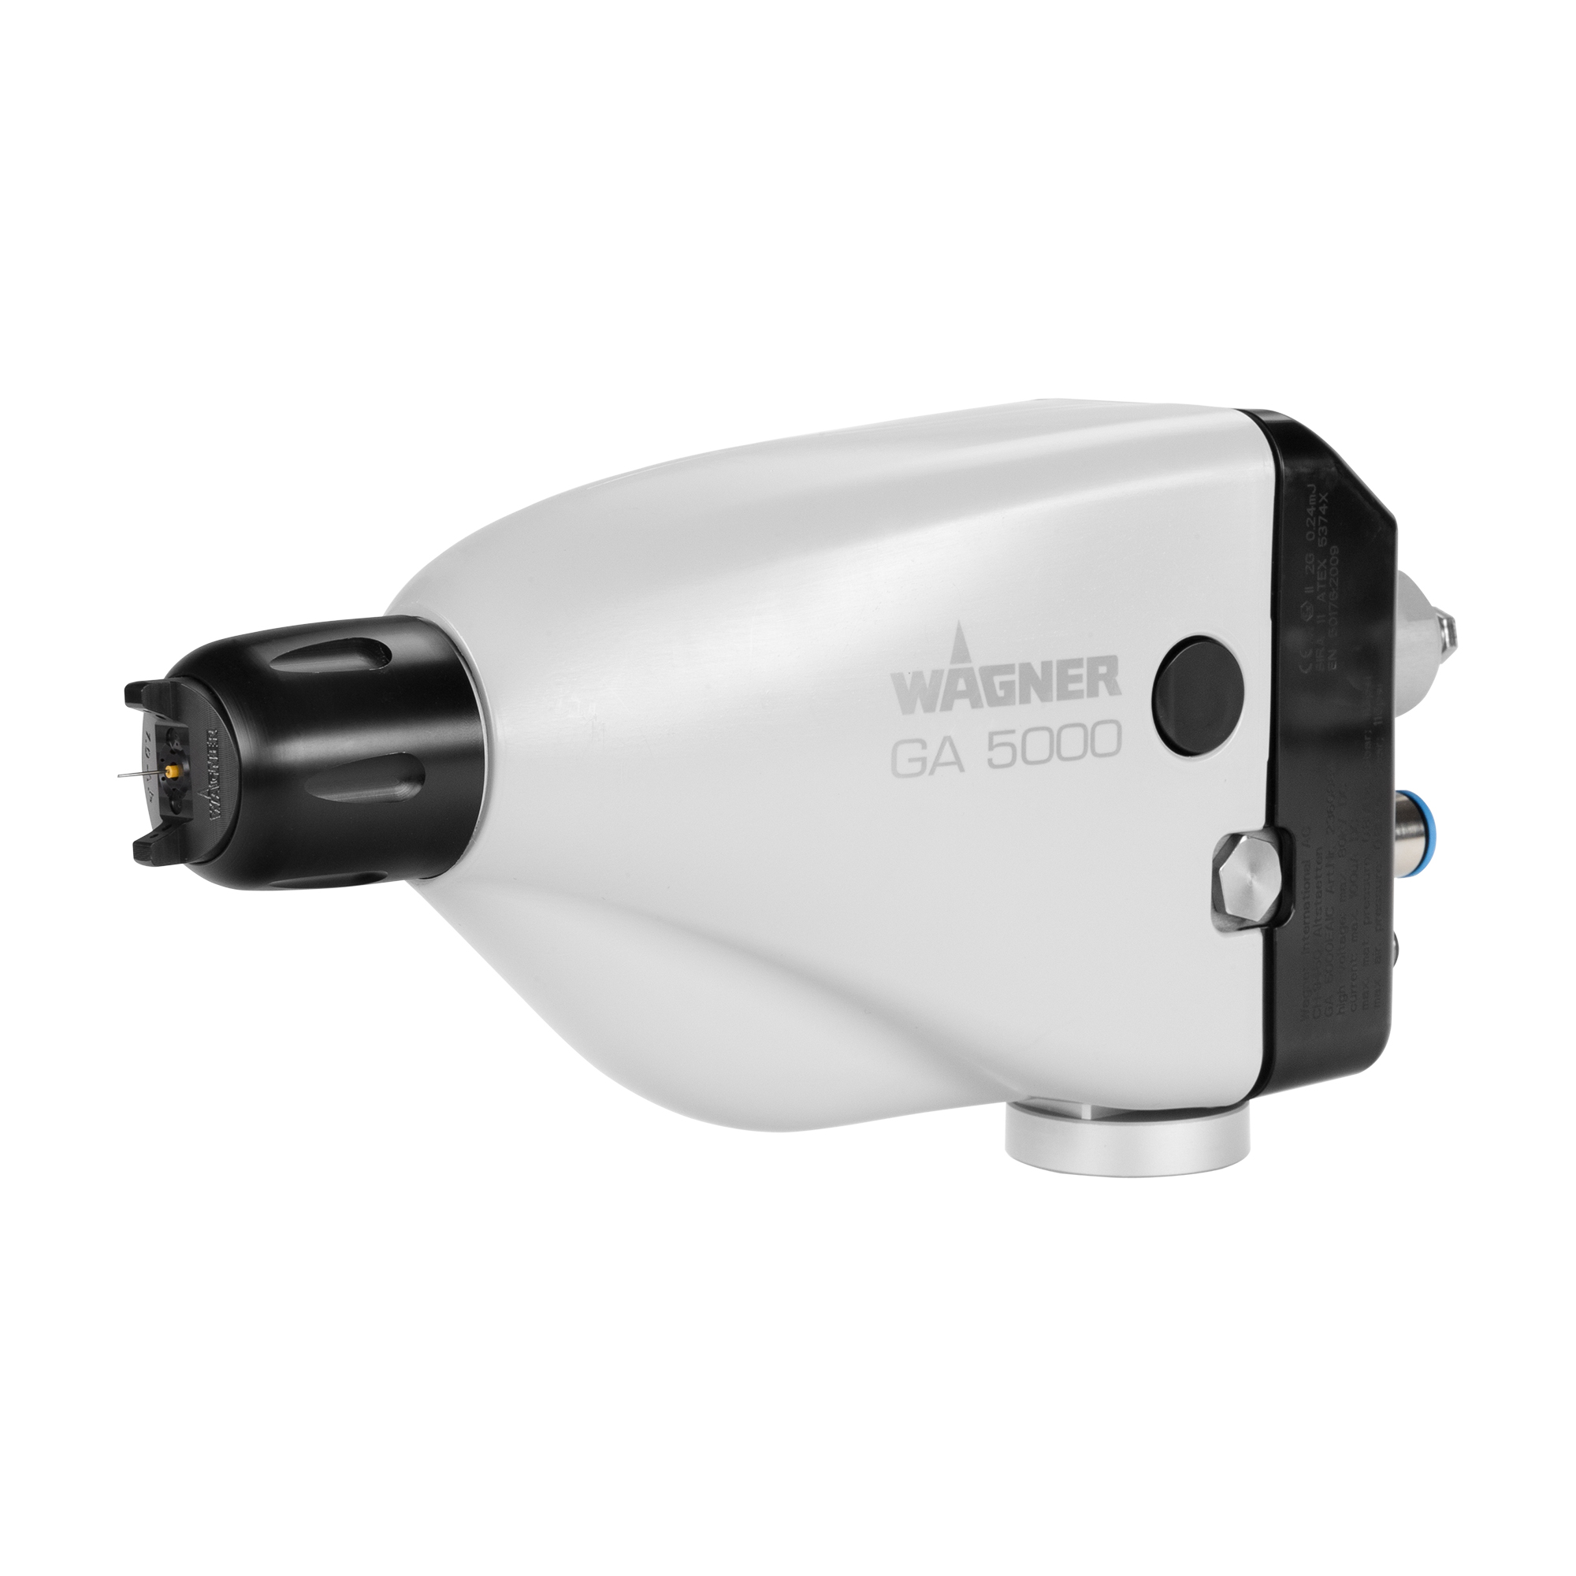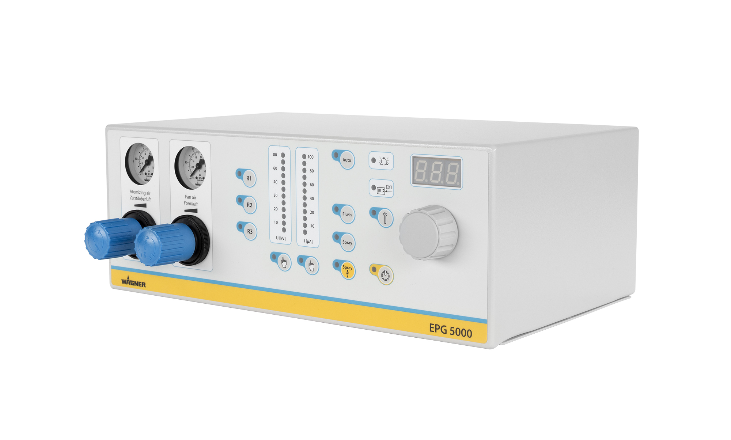

Further information:
https://www.wagner-group.com/en/products/industry/products/industry-productsliquid/applying/
https://www.wagner-group.com/en/products/industry/products/industry-productsliquid/product/control-unit-epg-5000/

